Headlines
Children learn new skills in computing lessons and enjoy the computing lessons we deliver.
They like a mixture of coding (computer science) and information technology
They feel safe online and know what to do if they do not feel safe (e-safety/digital literacy)
They are taught about a range of online safety issues and are aware of all of these

Actions
Make Computing clubs more accessible and consistent
Use computer/ipads during other lessons more frequently and purposefully during computing weeks
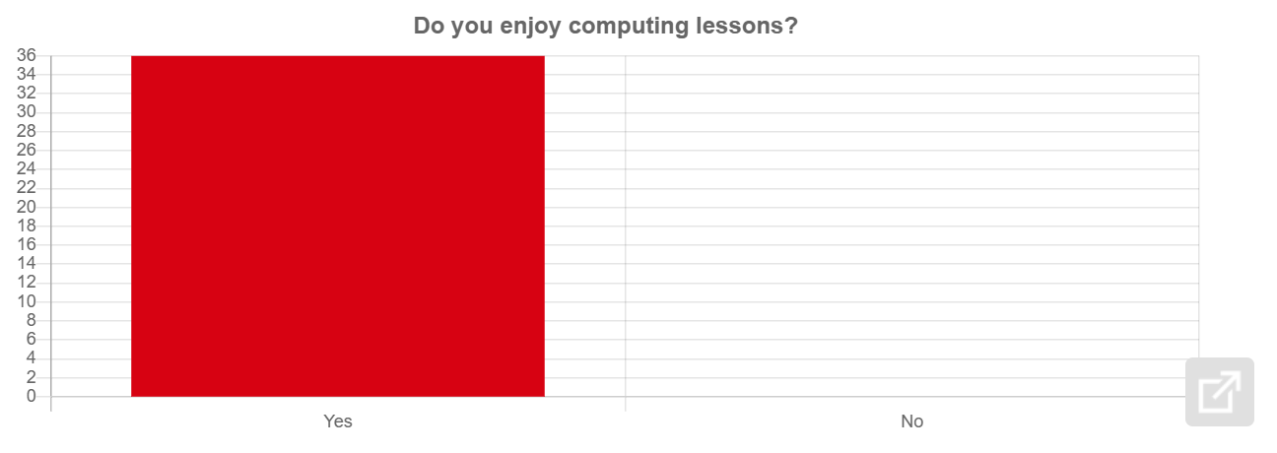

What do you enjoy the most about computing lessons in our school?
1 : Coding
2 : New games and powerpoints
3 : Coding and free time with our friends.
4 : Learning about coding
5 : I like using the laptops.
6 : Learning new things
7 : activitis
8 : PowerPoint
9 : LURNING
10 : Using powerpoint and doing coding
11 : Coding
12 : I like to do pour porns.
13 : PLAYING
14 : i like doing power ponts
15 : that we sometimes make power points
16 : doing this
17 : evrything
18 : Making Powerpoint
19 : Going on the powerpoint .
20 : we get to go online and get a break from writing
21 : powER POINT
22 : Coding
23 : POWER POINT
24 : Everything
25 : Everything
26 : how to type
27 : EVERTHING
28 : coding
29 : Temwani:power pionts which i really like.
30 : i love the drawing games and the racing game they are so fun
31 : I like coding and typing in things
32 : ACTIVITYS
33 : Coding
34 : power point
35 : coding
36 : I like making power points
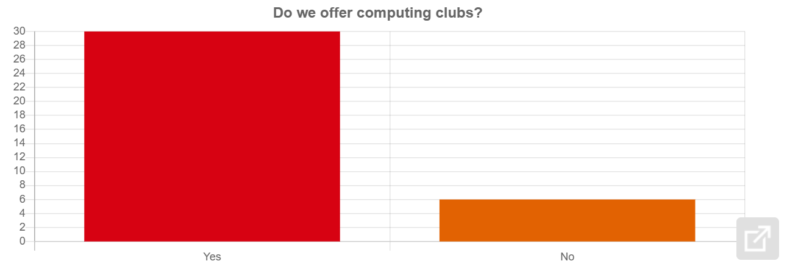
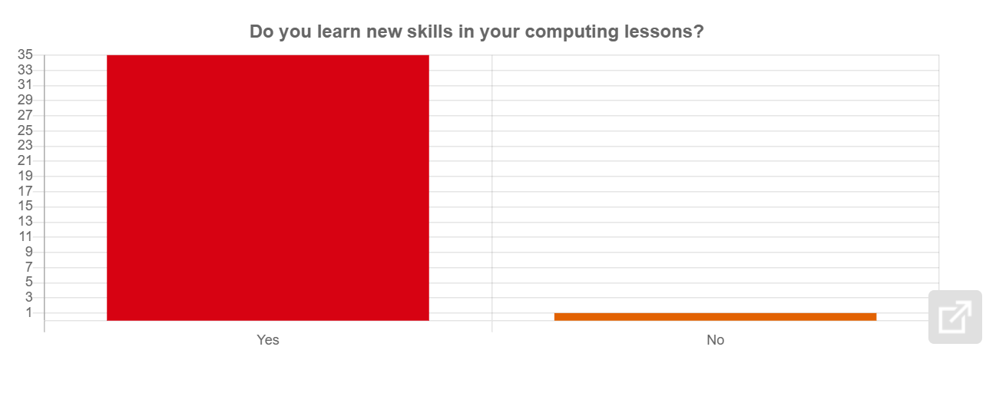
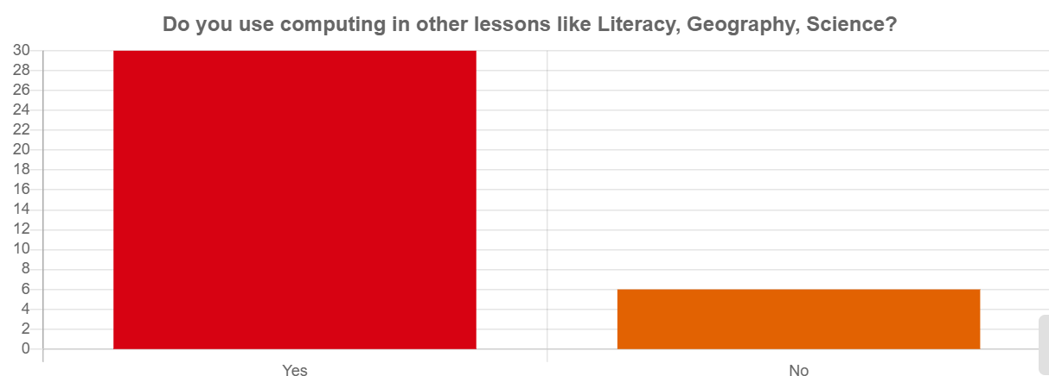
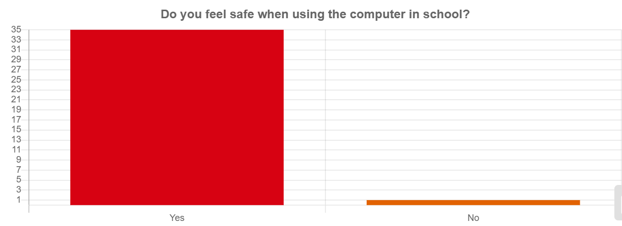
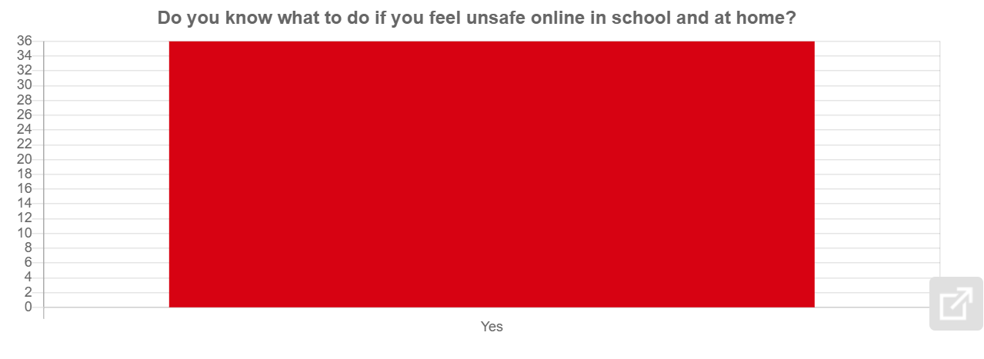
What does SMART stand for on your SMART poster?
1 : Safe
2 : S-smart M-meet A-accepting R-reliable T-tell
3 : Safe Meet Accepting Reliable Tell Be smart with a heart
4 : Safe Meet Accepting Reliable Tell
5 : Safe,meet,accepting,reliable,tell.
6 : Safe Meet Accepting Reliable Tell
7 : SAFE MEET ACCEPTING RELIAPLE TELL BE SMART WITH A HEART
8 : safe,meet,accpeting,reliable,tell.
9 : SAFE. MEET. ACCEPTING. RELIA
10 : S safe M meet A accepting R reliable T tell
11 : S safe M meet A accepting R reliable T tell
12 : s of save m of meet a of accepting r of reliable t of tell.
13 : SAFE,MEET,ACCEPTING,RELIABLE,TELL
14 : smart means s mean safe m means meet a means accepting r means reliable t means tell .
15 : S safe M meet A accepting R reliable T tell
16 : SMART means safe Meet Accepting Relatable Tell
17 : S M A R T .
18 : S=Safe m=meet a=accepting r=reliable t=tell
19 : safe,meet,accepting,reliable,tell,
20 : safe meet axept reliabul tell
21 : SAFE,MEET,ACCEPTING,RELIBLE,TELL!
22 : S=safe M=meet A=accepting R=reliable T=tell
23 : SAFE MEET ACCEPTING RELIABLE TELL !
24 : Smart means safe,MeetAccepting,Reliable,Tell
25 : Yas
26 : safe meet accepitng reliable tell
27 : SAFE.MEET.ACEPTING.RELIABLE.TELL
28 : safe meet accepting reliable tell be smart with a heart
29 : S=Safe M=Meet A=Accepting R=Reliable T=tell Temwani:
30 : s means save m means meet a means acception r means reliable t means tell
31 : Safe Meet Accepting Reliable Tell
32 : Smart you know things Meet accepting reliable tell
33 : Safe Meet Accept Reliable Tell
34 : Safe.Meet.accepting.Reliable.tell.
35 : Smart means safe,meet,accepting,reliable and teel.
36 : safe meet accepting reliable tell



