 |  |  | 
 | 
Mission Statement
Christ taught us to love one another.
As a school we follow his example, appreciating everyone as a unique gift from God.
We encourage each individual in the BEC Federation to achieve their true potential, giving them a firm foundation through love, learning and worship, to guide them on their journey through life.
Jesus said, “Love one another as I have loved you.” (John 13: 34)

RE Policy
Policy Type | Policy Number | Prepared by (job title) and date
Non-Statutory | NS06 | Executive Headteacher  Autumn 2025
Approval Date | Review Frequency | Review Due Date
02.12.25 | Annual | Autumn 2026
Signed on behalf of the Full  Governing Body 08/10/24 | G.M.Kendrick  (Chair of Governors) | 02.12.25

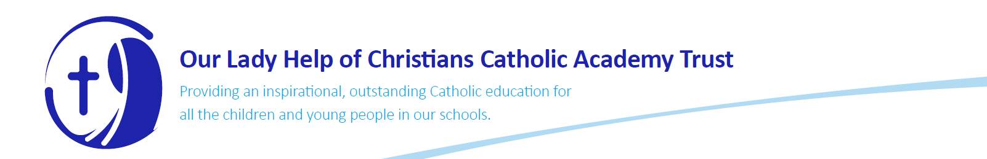
Introduction
Religious Education (RE) is the heart of all we do as Catholic schools and this permeates through every aspect of the curriculum and school life. We aim to provide the very best Catholic education for our pupils. Shrewsbury Cathedral Catholic Primary School and Nursery and St Patrick’s Catholic Primary School are learning communities underpinned by a Catholic ethos based upon Gospel values. We aim to celebrate the uniqueness of every child, enabling each to reach his or her potential spiritually, morally, academically and socially.
In this policy we aim to set out the aims for the Religious Education Policy, explain how Religious Education is planned, taught and assessed, explain how the SLT monitors and reports on Religious Education and explain how Religious Education is set in the context of the world we live in.
The BEC Federation Mission Statement for children
We Work, We Love, We Learn, We Pray – we spread the Gospel message everyday.

Christ taught us to love one another.
As a school we follow his example, appreciating everyone as a unique gift from God.
We encourage each individual in the BEC Federation to achieve their true potential, giving them a firm foundation through love, learning and worship, to guide them on their journey through life.
Jesus said, “Love one another as I have loved you.” (John 13: 34)

Aims:
- To promote the Catholic ethos of the school through prayer, reflection, forgiveness, reconciliation, celebration and liturgy.
- To present a comprehensive content which engages pupils and is the basis of knowledge and understanding of the Catholic faith. To fulfil our aims and objectives we use the ‘The Vine and The Branches’ and ‘The Way, the Truth and the Life’ programme of Religious Education recommended by the Diocesan RE Advisory Service. The aim of these programmes is to explore the religious dimension of questions about life, dignity and purpose within the Catholic tradition. Central to the The Way, the Truth and the Life programme and The Vine and the Branches are three basic human questions and the three Christian beliefs that are the Church’s response in faith:

Where do I come from? Life < > Creation
Who am I? Dignity < > Incarnation
Why am I here? Purpose < > Redemption
- To encourage and develop links with family, Parish and diocese and to provide a framework for Sacramental preparation that is mindful of the needs of all.
- To enable pupils continually to deepen their religious and theological understanding and be able to communicate this effectively;
- To present an authentic vision of the Church’s catholic social teaching so that pupils can make a critique of the underlying trends in contemporary culture and society;
- To raise pupils’ awareness of the faith and traditions of other religious communities in order to respect and understand them;
- To develop the critical faculties of pupils so that they can relate their Catholic faith to daily life;
- To stimulate pupils’ imagination and provoke a desire for personal meaning as revealed in the truth of the Catholic faith;
- To enable pupils to relate the knowledge gained through Religious Education to their understanding of other subjects in the curriculum;
- To bring clarity to the relationship between faith and life, and between faith and culture.
- To provide a framework for teaching Relationship, Health and Sex Education that takes into account the needs of the child, the family and the Church.
Organisation of the Religious Education Policy
- Legislation and guidance – National Curriculum - INTENT
- Roles and responsibilities – IMPLEMENTATION
- Organisation and planning - IMPLEMENTATION
- Inclusion - IMPLEMENTATION
- Monitoring and Assessment arrangements - IMPACT
- Links with other policies
- Appendix

1.Legislation and guidance – National Curriculum - INTENT
Religious Education is a core subject in our school, alongside English, Maths and Science, and therefore we devote 10% of our curriculum time to its delivery. It is the heart of all we do as Catholic schools and permeates through every aspect of the curriculum and school life. We aim to provide the very best Catholic education for our pupils. Shrewsbury Cathedral Catholic Primary School and Nursery and St Patrick’s Catholic Primary School are learning communities underpinned by a Catholic ethos based upon Gospel values. We aim to celebrate the uniqueness of every child, enabling each to reach his or her potential spiritually, morally, academically and socially.
We strive to achieve this aim through the everyday routine /general and prayer life of the school, as well as Religious Education and to achieve high standards and encourage pupils to make the most of the opportunities we offer them. We adhere to the Curriculum Directory guidelines and learning outcomes. This provides a cohesive approach and opportunities for whole school assemblies and celebrations as well as displays which are relevant to every child. The core of our curriculum is based on the Way The Truth and the Life and The Vine and The Branches scheme of work. These themes are developed with greater depth and breadth each year as the child progresses through the school and will form the core of our Religious Education studies.
In the daily living out of our Catholic faith, we aim to ensure that religious education and spiritual development will be threaded through every aspect of the curriculum, so that it is explicit and implicit within the taught curriculum. Rooted in prayer and lived out in the daily life of the school, the children are supported, through the curriculum, to grow in faith and deepen their relationships with God and each other.
2. Roles and responsibilities – IMPLEMENTATION
Our curriculum is shaped by our school vision, to STRIVE to be the best we can be for the Glory of God.
We ensure that a minimum of 10% of Curriculum time is allocated for RE teaching across all key stages. The requirements of the RE curriculum are met through the scheme ‘The Way the Truth and The Life’ and ‘The Vine and The Branches’ which in turn meets the requirements of the Religious Education Curriculum Directory set out by the Bishop’s Conference of England and Wales. The scheme provides the basis for teaching the doctrines of the Catholic Church. We ensure that this programme of study is enriched with a variety of activities that include drama, history, geography, art and ICT.
We recognise that the school has a special part to play in supporting parents who strive to develop a lasting faith commitment within their child. Together we guide them to a meaningful relationship with God, with Jesus, the Word of God, and with the Holy Spirit, who guides our every action.
In school, we do this in three main ways;
- by creating an atmosphere which pervades the whole life of the school, where the unique value of each person is recognised and respected. The most powerful agent in this process is the example of Christian behaviour and attitudes shown by all members of staff through their actions and words, and in the relationships they foster.
- by creating a structured liturgy appropriate to the age and ability of the children. In partnership with our parish priest, opportunities are created for prayer and worship closely matching the liturgical calendar. School Masses, assemblies and services are all important elements in our liturgy.
- by delivering a planned programme of Religious Education.
The children explore the religious dimensions of questions about life, dignity and purpose within the Catholic tradition. Links are made with the pupils’ own experiences and with the other faith traditions.
We proudly proclaim our faith and invite all to join us on our journey, but we welcome children and families of other faiths to our community, and we learn about other faiths and cultures.
Curriculum Overview for The Way, The Truth and The Life
 | Autumn 1 | Autumn 2 | Spring 1 | Spring 2 | Summer 1 | Summer 2
Nursery | God’s Wonderful World | My Family | The Holy Family | Good Friends | New Life | Our Church Family
Reception | God’s World | God’s Family | Getting to Know Jesus | Sorrow and Joy | New Life | Our Church Family
Year 1 | God’s Great Plan | Mary, Our Mother | Families and Celebrations | Following Jesus | The Resurrection | Miracles
Year 2 | Chosen People | Mysteries | The Good News | The Mass | Eastertide | The Church is Born
Year 3 | Christian Family | Mary, Mother of God | Sacrament of Reconciliation | Celebrating the Mass | Celebrating Easter and Pentecost | Being a Christian
Year 4 | The Bible | Trust in God | Jesus the Teacher | Jesus the Saviour | Early Christians | The Church
Year 5 | Creation | Creation | God’s Covenants | Inspirational People | Reconciliation | Life in the Risen Jesus
Year 6 | The Kingdom of God | Justice | Exploring the Mass | Jesus the Messiah | The Transforming Spirit | Called to Serve

Reception, use the RE level descriptors from the Bishops’ conference to assess the attainment of the children and their progress is tracked on a termly basis. Teachers also highlight ‘statements’ which reflect the children’s learning across a unit on the front cover. The Foundation Stage use the assessment profile to assess. Children are assessed on their individual, group and oral work through each topic. This enables both class teachers and the subject leader to monitor coverage and identify progress made throughout the pupils’ time at school.

Curriculum Overview for The Vine and The Branches
Each year group will tach six branches:
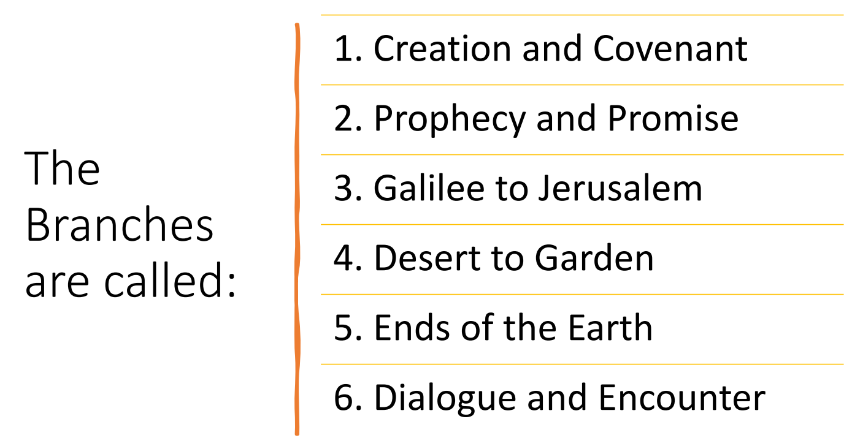
Years 1-6 will use the lenses and ways of knowing to assess the attainment of the children and their progress is tracked on a termly basis. Teachers also highlight and date the lenses and ways of knowing which reflect the children’s learning across a unit on the front cover. Children are assessed on their individual, group and oral work through each topic. This enables both class teachers and the subject leader to monitor coverage and identify progress made throughout the pupils’ time at school.

Religious Education is the responsibility of the R.E. co-ordinator / Executive Headteacher with support from the teachers. Their role is to monitor and assess the Religious Education curriculum and Catholic prayer and worship throughout the school to ensure continuity and progression. They also ensure that the aims and learning outcomes in the Curriculum Directory are identified and fulfilled. A link governor has specific responsibility for Religious Education and liaises closely with the staff of the school to fulfil their monitoring duties.

The Religious Education Co-ordinator will be responsible for:
- Working with senior leaders and monitoring teaching and learning, planning and standards through lesson observations and work scrutinies according to school practice.
- Organising in-house moderation of standards meetings.
- Self-evaluation to identify strengths and areas for development.
- Ensuring the curriculum offered is appropriate, suitable and relevant to pupils’ needs and interests.
- Attend appropriate training and keeping up to date with current thinking, policy and developments and feeding back to staff.
- Organising and leading in-house staff training and development.
- Identifying training needs of staff to ensure their suitability to teach effective Religious Education.
- Supporting and advising colleagues in the delivery of Religious Education.
- Liaising with the Executive Headteacher, Governors, parents, the Education Service on matters relating to Religious Education.
- Auditing, managing and developing resources within a given budget.

Class teachers
Teachers will:
- Have a clear understanding of the requirements for Religious Education in their year group and Key stage and reinforce them wherever possible.
- Plan, teach and assess Religious Education in accordance with the school’s schemes of work – The Way, The Truth and The Life or The Vine and The Branches.
- Handle Religious Education topics sensitively and confidentially where appropriate.
- Seek advice whenever they are unsure in what they are delivering.

Governors
Governors are responsible for:
- Ensuring that the Religious Education policy is in keeping with the Catholic teaching advocated by the Diocese and is implemented by the school
- Ensuring that the policy is available to parents
- Ensuring that the programme and the resources are suitably monitored and evaluated

Planning
The BEC Federation uses The Way, the Truth and the Life as the scheme of work - www.dioceseofleeds.org.uk/education/education/primary/way-truth-life.php (reception) or The Vine and The Branches - https://digital.tere.org/ (years 1-6) . The learning themes and intentions from these schemes of work are used as the starter for the teacher’s planning. For example, all teachers use the suggested planning framework from the Leeds Diocese or from teacher’s book (The Vine and The Branches). All teachers are expected to look at the content of a lesson and plan appropriate creative activities, which reflect the learning intentions. These can where relevant link with global issues and cross-curricular links especially with RHSE, Citizenship and Geography. At least 10% of curriculum time is given for RE and RE in BEC Federation is considered a core subject. As a Federation, we use CAFOD’ resources so that a global dimension can be added to our schemes of work when it is appropriate. As a school, we also keep up to date with the current CAFOD campaigns and these are used as part of RE teaching where it is considered to be appropriate.
All teachers will give due consideration to the following points when planning for Religious Education:
- Prior learning
- Sharing objectives
- Children’s ideas
- Artefacts and resources
- Learning styles and pace
- Use of ICT
- Christ at the centre of the lesson
- Use of prayer – pupil led/pupil input,
- Different methods of prayer and
- Reflection, traditional
- Music – pupil choice, children singing
- Challenge and differentiation
- Collaboration between staff and pupils

Children will contribute to the planning where applicable, including the planning of assemblies, Celebration of The Word (refer to the Prayer and Liturgy Policy) and celebrations. Links will also be made with the children’s own experience. This may include experience of other world faiths.
Wherever possible, opportunities will be planned to:
- Make links with the Parish including working with the priest
- Visit museums and galleries
- Work with artists, authors and performers
- Develop openness towards music and dance of other cultures
- Appreciate the natural world through Art and Literature
- Recognise the contribution made by other cultures to Art, Mathematics, Science and
- Technology
- The cultural activities and traditions of others will be planned for the whole school, and

World Faiths
We aim for our children to accept that we are part of a world religious family within which national, racial and cultural differences should never introduce division. We want our children to understand, appreciate and gain from other religious traditions by approaching and learning in a spirit of openness and humility.
Our aims are:
- To understand that we are all children of God
- To look at, learn about and understand other faiths and cultures
- To develop a knowledge and appreciation of the skills in music and art of other faiths and communities
- We will portray Britain as a multi-faith society and endeavour to present a contemporary picture. With this in mind, we will also consider teaching about World Faiths when this is most relevant during the academic year, for example – during a festival or significant time of year for particular religions.
- Through our teaching about world faiths, we hope that our children will recognise that we can learn a lot about ourselves and our Catholic Faith by developing our understanding of all religious traditions. Our key message will be of respect.

Cultures
As well as learning about world faiths, we want our children to appreciate their own cultural traditions. In our culturally rich society, we value contributions from pupils and adults from all cultural backgrounds. We promote a positive ethos for bi-lingual children in our school and we encourage our children to participate in cultural activities and traditions by:
- Exploring times and cultures different from our own
- Welcoming visitors from other cultures to our school
- Making use of our local community in our studies
- Making use of resources available to us
- Visiting places of cultural or historical significance, tradition or perspective
- Children and staff will use all aspects of the curriculum – Literacy, History, Geography,
- RHSE, Art, Music, Dance, Drama – to participate in, and to appreciate, their own and other cultural traditions.

Resources
Apart from year group The Way, the Truth and the Life and The Vine and The Branches books and individual class artefacts, RE resources are stored centrally. If you are unsure of what resources to use or what resources are available, please contact the Senior Leadership Team.

These resources include the following:
• Bibles and religious story books
• Prayer books
• Teacher Information Books
• Artefacts – boxes of artefacts for Christianity, Judaism, Sikhism, Islam, Hinduism
• Posters and display material
• CAFOD videos, resource packs, posters

Websites: www.cafod.org.uk & www.edurcdhn.org.uk & www.cesew.org.uk & www.tere.org.uk

4. Inclusion – IMPLEMENTATION
We believe that all children should have the opportunity to be included in Religious Education and support those children with Special Educational Needs. Children who are noted to be Gifted and Talented in this area are encouraged to share their talents with the school community, and their gifts to be enhanced through appropriate differentiation.
5. Monitoring and Assessment arrangements – IMPACT
By the time children leave the children will:
- Live out the Gospel values and virtues.
- Have a deeper appreciation of their faith and fulfil their God-given talents.
- Have respect for themselves and others.
- Be well prepared for the next stage of their education as confident and enthusiastic learners
- Produce good quality work which they are proud of.
- Achieve consistently well in all areas of Religious Education and make good progress.
- Be happy, well-rounded individuals who have developed a deep-rooted relationship with God and understanding of their Catholic faith.
- Be ambassadors for Christ who are ready to go out into the world and proclaim the values of the Gospel confidently, building the Kingdom of God through compassion, justice, love and forgiveness in their relationship with others.
- Understand that they are part of the family of God and know how they can play their part in this Global family united by Christ.

We hope that as children leave to further their education and learning that they continue to access fundamental skills including:
- Having thought about their own spiritual development.
- Being trusted when interacting and working with others.
- Increased resilience to continue trying and improving through a process of
- self-reflection.
- An inquisitive nature to ask questions to explore their own beliefs.
- Being valued both individually and as part of a team.
- A sense of exceptional achievement.

Assessment Practice
Assessment establishes what children know and understand and can do. It does not assess faith or the practice of faith. Assessments are based on observations, artwork, discussion notes, photos and as well as written work. These are then used to inform future planning. The children’s book are the primary source of evidence. Each term one unit of work will be formally assessed following guidance from the Shrewsbury Diocese. The assessment sheet is kept in the child’s book including dated reference to the pieces of work and the highlighted front sheet.
Moderation of the children’s work will happen during staff meeting. The RE Co-ordinator and SMT will monitor planning, teaching and assessment on a regular basis.
RE is included on the children’s annual reports and is also discussed with parents at termly parents’ evenings.

6.Links with other policies

- Prayer and Liturgy
- Relationships Health and Sex Education
- Behaviour Policy

